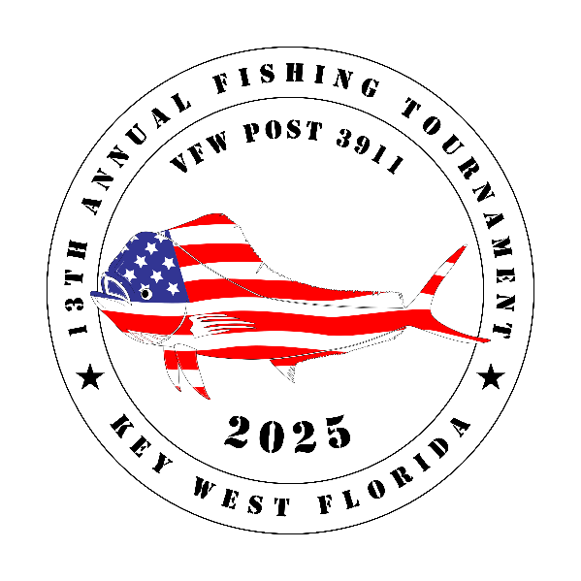

Dear Friends,

The Veterans of Foreign Wars, Post 3911, Key West will hold their 13th annual fishing tournament **June 20th thru June 22nd, 2025.** The primary purpose of this tournament is to raise money for needy veterans, along with active duty who are in severe financial straits.

All proceeds raised through this tournament will go to the VFW Post 3911 for use in Monroe County FL. The VFW Fishing Tournament has no paid employees and therefore 100% of the money raised will go to VFW Post 3911 to help those in need.Wehope that you will consider becoming a corporate sponsor. The levels are:  **Platinum - $2500; Gold - $1000.00; Silver - $500.00**. We also need donations of goods/services for door prizes and for the captains’ bags.

All donations are fully tax deductible as the VFW Post 3911 is a 501(c) (19) non-profit and a 501(c)(3) organization. All checks should be made out to VFW Post 3911 and sent to the address below. Should you have any questions, please do not hesitate to contact us.

***Help us help those who gave so much!***

Wayne Russano, Tournament Director

Phone: 770-630-3570 Email: vfw391110@yahoo.com

Pete Thomas, Associate Director

Phone: 610-304-2392 Email: vfw391110@yahoo.com

**Veterans of Foreign Wars Post 3911**

**2200 N. Roosevelt Blvd.**

**Key West, Florida 33040**

**Website: post3911.org Email: vfw391110@yahoo.com**

**Veterans of Foreign Wars, Post 3911 is a 501(c)(19) and a 501(c)(3) non-profit organization**

\*\*\*\*\****ALL SPONSORS GET A COLOR LOGO ON THE TROURNAMENT BANNER!\*\*\*\*\****

# Platinum Sponsors $2,500

**8 Tournament Shirts**

**8 Tickets to Award BBQ**

**ExtraLarge color logo on Tournament Banners**

#### Gold Sponsors $1,000

**4 Tournament Shirts**

**2 Tickets to Award BBQ**

**Large color logo on Tournament Banners**

### Silver Sponsors $500

**2 Tournament Shirts**

**1 Tickets to Awards BBQ**

**Medium color logo on Tournament Banner**

#### Bronze Sponsors $250

**1 Tournament Shirt**

**1 Tickets to Award BBQ**

**Small color logo on Tournament Banners**

***\*To have logo on Tournament Sponsor Banner, a signed commitment must be received by May 1st.***

**Return last page to Wayne Russano, c/o VFW Post 3911** [vfw391110@yahoo.com](mailto:vfw391110@yahoo.com)

Business Name

Contact Person

Contact Phone #

Contact Email

Shirt Sizes **4XL_______ 3XL_______ 2XL_______ XL_______ L_______ M_______S_______**

I hereby pledge the above amount and will pay by June 1st, 2025.

__________________________________ ___________________________________

**Print name Signature**